Environment: ☐Quality / Validation ☐ Training ☒ Production ☐ Other ____________ | Test Run: 1

Test-Step No. | Screenshot | Comment
1 | Before screenshot was inadvertently missed | Before
2 | 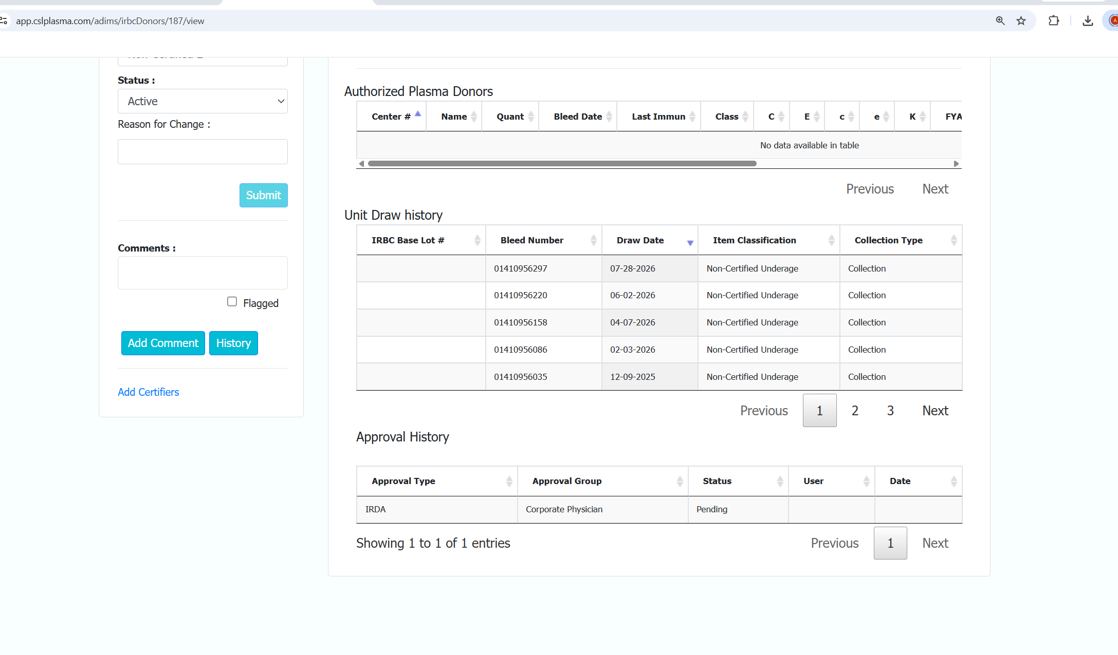 | After

- Summary and Post Execution Approval
Comments  (Statements relevant to test outcome or test execution e.g. reason for partial execution) | The approval task for Whole Blood Donor was created manually by running insert query in production.  User confirmed that the approval task is visible in the approvals dashboard.
Test Outcome (Pass/Fail) | ☒Passed ☐ Failed
Defect No.
Print Name of Tester |  | Date | Signature | Initials
Pradeep Vishwakarma |  | 09-OCT-2026
Print Name of Test Verifier |  | Date | Signature | Initials
☒ Check this box if this executed test will be reviewed and verified in Veeva
Note: Fields not used on the form must be voided with a line or N/A.

